 This a copy from the Gimp Open Image Box

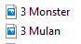 This is from File Explorer

